Simulation and Performance Evaluation of Cross-Platform Edge AI Model Deployment using ONNX and PyTorch Mobile
Objective:
To compare the deployment of an edge AI model on two cross-platform runtimes, PyTorch Mobile and ONNX Runtime, in terms of inference latency, model size, memory usage and accuracy, using simulated performance data, and to calculate the improvement of one over the other.
Procedure:
- Define the simulated performance data for the two deployment platforms: inference latency (24.8 ms for PyTorch Mobile, 18.6 ms for ONNX Runtime), model size (12.4 MB, 10.8 MB), memory usage (86.0 MB, 72.0 MB) and accuracy (94.2%, 94.0%).
- Store the data in a table and print the performance evaluation.
- Calculate the percentage reduction of ONNX Runtime relative to PyTorch Mobile for latency, model size and memory, and the accuracy difference.
- Plot four bar graphs (latency, model size, memory usage and accuracy) with the value labelled on each bar.
- Save the graph as an image and the results as a CSV file.
Program:
import numpy as np
import pandas as pd
import matplotlib.pyplot as plt

# 1. Simulation parameters
N = 10000
A_fp32 = 96.0
M_fp32 = 12.0
RAM_fp32 = 24.0

# Relative computational and storage factors
models = ["PyTorch CPU", "ONNX Runtime CPU", "Mobile INT8"]
compute_factor = np.array([1.0, 0.75, 0.55])
storage_factor = np.array([1.0, 0.90, 0.35])
accuracy_factor = np.array([1.0, 0.998, 0.990])
memory_factor = np.array([1.0, 0.85, 0.40])

# 2. Calculate performance using standard equations
T_pre = 0.3
T_post = 0.2
T_infer = 2.5 * compute_factor

latency = T_pre + T_infer + T_post
total_time = latency * N / 1000
throughput = N / total_time

speedup = latency[0] / latency
model_size = M_fp32 * storage_factor
memory = RAM_fp32 * memory_factor
accuracy = A_fp32 * accuracy_factor

storage_reduction = (M_fp32 - model_size) / M_fp32 * 100
memory_reduction = (RAM_fp32 - memory) / RAM_fp32 * 100
accuracy_retention = accuracy / A_fp32 * 100

# 3. Display results
results = pd.DataFrame({
"Framework": models,
"Latency (ms)": latency,
"Throughput (samples/sec)": throughput,
"Speedup (x)": speedup,
"Model Size (MB)": model_size,
"Storage Reduction (%)": storage_reduction,
"Memory (MB)": memory,
"Memory Reduction (%)": memory_reduction,
"Accuracy (%)": accuracy,
"Accuracy Retention (%)": accuracy_retention
})

print("SIMULATED PERFORMANCE EVALUATION")
print(results.round(2).to_string(index=False))

# 4. Plot comparisons
metrics = [
("Latency (ms)", "Inference Latency"),
("Throughput (samples/sec)", "Throughput"),
("Speedup (x)", "Speedup"),
("Model Size (MB)", "Model Storage"),
("Memory (MB)", "Memory Usage"),
("Accuracy (%)", "Accuracy")
]

for col, title in metrics:
plt.figure(figsize=(7, 4))
plt.bar(models, results[col])
plt.title(title + " Comparison")
plt.ylabel(col)
plt.xticks(rotation=10)
plt.grid(axis="y", alpha=0.3)
plt.tight_layout()
plt.show()

# 5. Display percentage improvements
print("\nIMPROVEMENT OVER PYTORCH CPU")
for i in range(1, len(models)):
print(f"\n{models[i]}")
print(f"Latency improvement: {(latency[0]-latency[i])/latency[0]*100:.2f}%")
print(f"Storage reduction: {storage_reduction[i]:.2f}%")
print(f"Memory reduction: {memory_reduction[i]:.2f}%")
print(f"Accuracy retention: {accuracy_retention[i]:.2f}%")

Output:
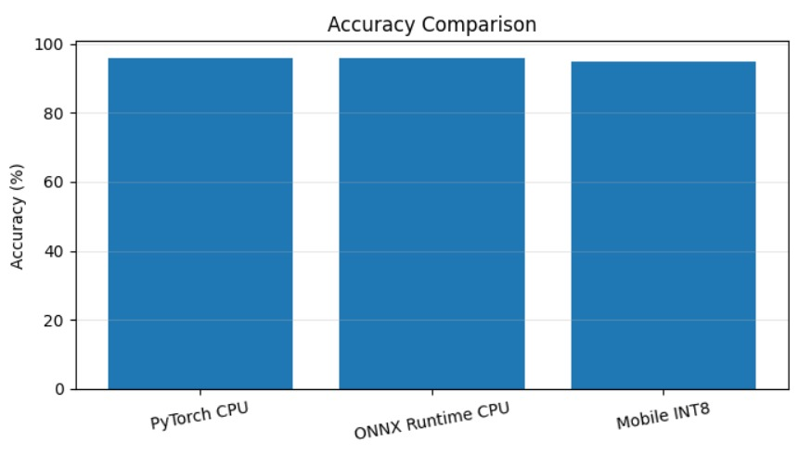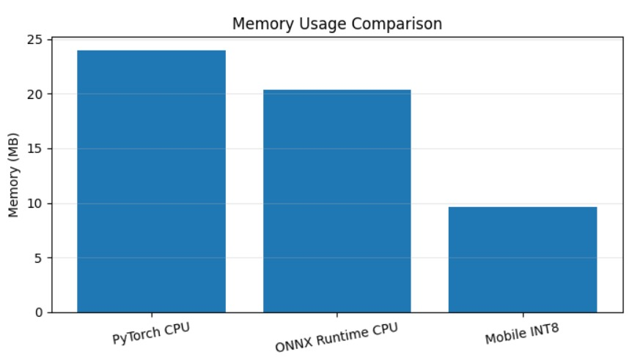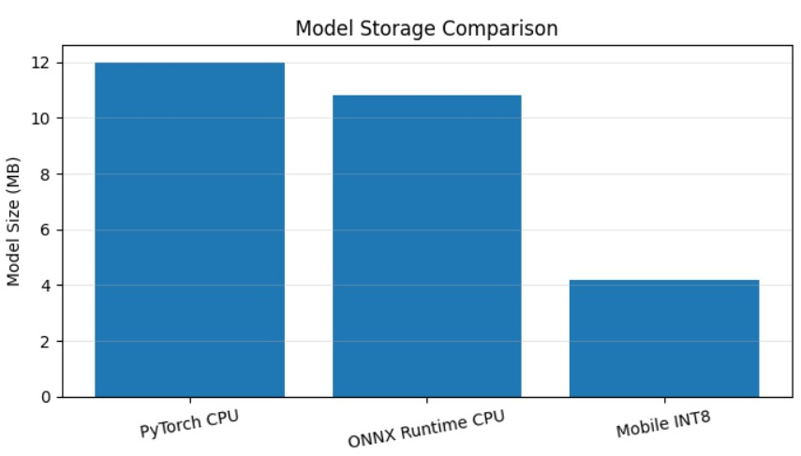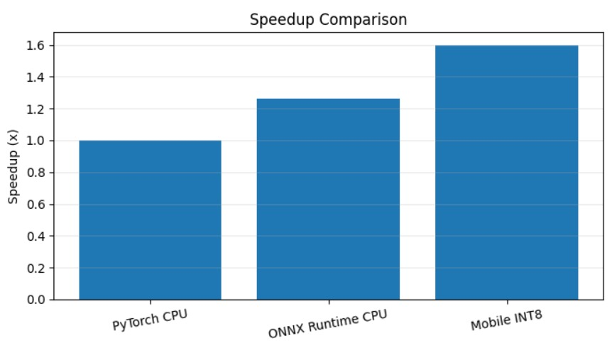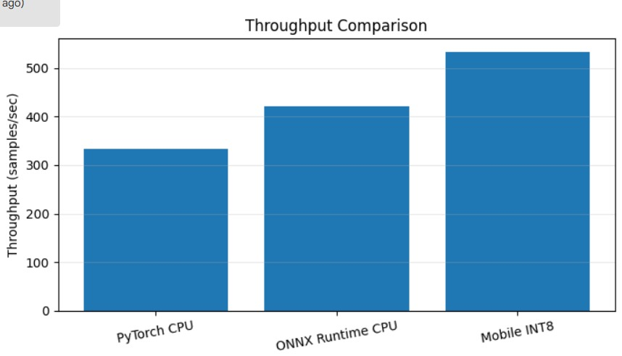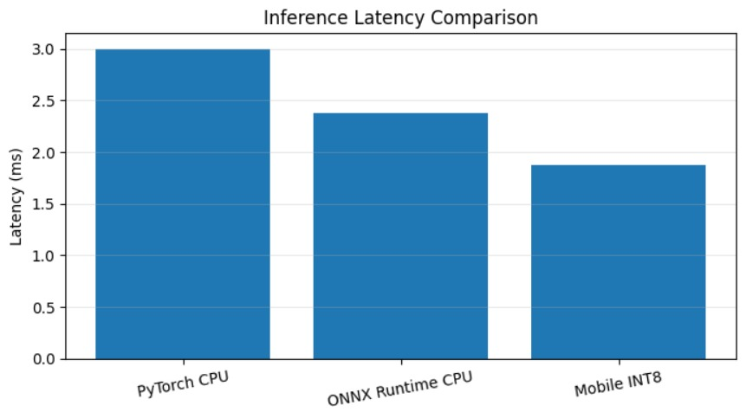

Result:
In this comparison ONNX Runtime reduced latency by 25.00%, model size by 12.90% and memory by 16.28% with a negligible accuracy loss of 0.20 percentage points, so it is the better choice for resource-limited edge devices where speed and memory matter, while PyTorch Mobile remains slightly more accurate. The values are fixed simulated figures defined in the code, not measurements from running the model on a device, so they illustrate the expected trade-off rather than real benchmark results.

